**SQL Exercise - Advanced concepts**

***Exercise 1: Ranking and Window Functions***

**1)Code**

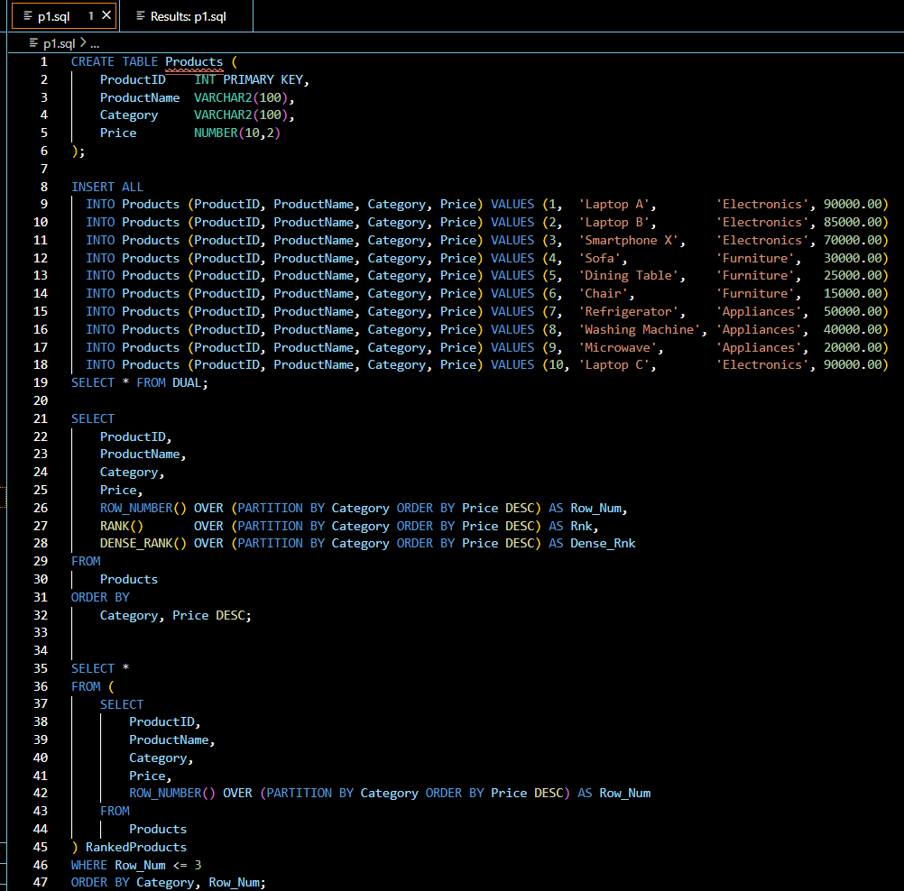

**2)Output**

